Table 1 Site conditions
Altitude (m) | Vegetation type | Dominanted species | MAT (℃) | MAP (mm) | Soil depth (cm) | Bulk density  (g cm⁻³) | pH (H₂O) | Soil texture (%)
 |  |  |  |  |  |  |  | Sand | Slit | Clay
690 | Subtropical evergreen broadleaf forest (EBF) | Castanopsis carlesii,  Castanopsis eyrei | 18.5 | 1700 | 0-10 | 0.87 | 4.54 | 40.3 | 45.5 | 14.2
 |  |  |  |  | 10-25 | 0.89 | 4.82 | 38.1 | 48.9 | 13.0
 |  |  |  |  | 25-40 | 0.96 | 4.94 | 41.7 | 37.1 | 21.2
1140 | Coniferous forest (CF) | Pinus taiwanensis, Oligostachyum oedogonatum | 14.5 | 2000 | 0-10 | 0.64 | 4.64 | 50.3 | 37.1 | 12.6
 |  |  |  |  | 10-25 | 0.77 | 4.79 | 46.9 | 38.3 | 14.8
 |  |  |  |  | 25-40 | 0.87 | 4.88 | 43.1 | 42.0 | 14.9
1750 | Subalpine dwarf forest (SDF) | Symplocos paniculata, Stewartia sinensis | 11.2 | 2200 | 0-10 | 0.61 | 4.59 | 45.9 | 40.7 | 13.4
 |  |  |  |  | 10-25 | 0.79 | 4.84 | 44.1 | 42.3 | 13.6
 |  |  |  |  | 25-40 | 0.82 | 4.91 | 41.5 | 45.4 | 13.3
2060 | Alpine meadow (AM) | Calamagrostis brachytrich,  Miscanthus sinensis, Lycopodium clavatum | 9.7 | 3100 | 0-10 | 0.54 | 4.86 | 34.7 | 48.6 | 16.7
 |  |  |  |  | 10-25 | 0.65 | 5.13 | 30.3 | 54.4 | 15.3
 |  |  |  |  | 25-40 | 0.80 | 5.22 | 35.4 | 38.8 | 25.8
Note: MAT, mean annual temperature; MAP, mean annual precipitation. Datasets of MAT and MAP are obtained from He and others (1994), Zheng and Fang (2004), and Wang and others (2009). Datasets of bulk density, pH and soil texture are obtained from Bu and others (2010).

Fig. 1 Map of headwater streams in the evergreen broadleaf forest (EBF), coniferous forest (CF), subalpine dwarf forest (SDF) and alpine meadow (AM) in the Wuyi Mountain National Nature Reserve of southeastern China.

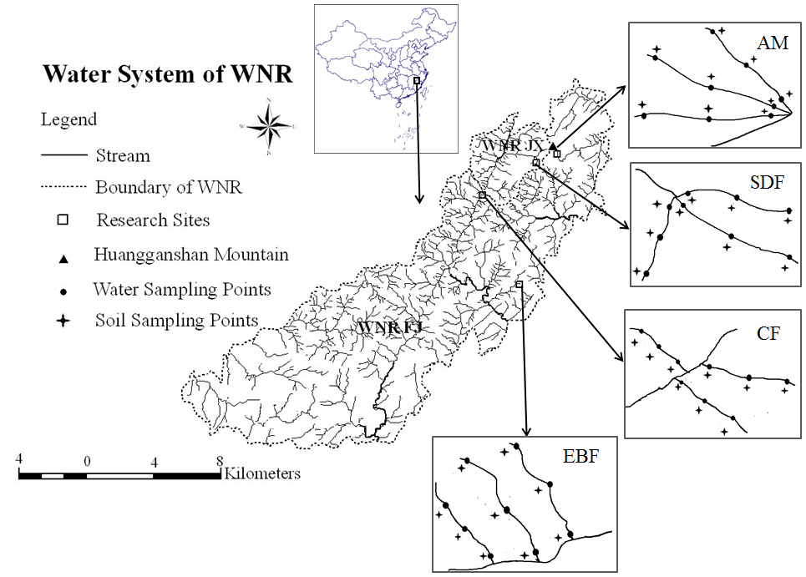

Note: WNR, Wuyi Mountain National Nature Reserve; FJ, Fujian Province; JX, Jiangxi Province.

Fig. 2 Annual mean values in (a) headwater stream DOC concentrations, (b) SOC contents, (c) WSOC contents, (d) soil C:N ratio, (e) temperature, and (f) headwater stream dissolved N concentrations (mean±SD, n=3) along an altitudinal gradient in the Wuyi Mountains of China (S1: 0-10cm soil depths; S2: 10-25cm soil depths; S3: 25-40cm soil depths). Signiﬁcant differences between the means are marked with different letters.

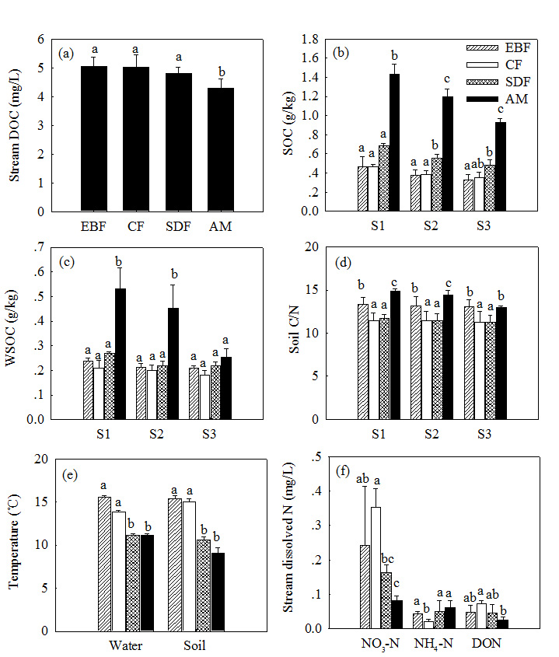
Fig. 3 Correlations between annual mean headwater stream DOC concentrations and (a) altitude, (b) SOC contents, (c) WSOC contents, (d) soil C:N ratio, (e) temperature, (f) headwater stream dissolved N concentrations along an altitudinal gradient in the Wuyi Mountains of China. (n=12; * and ** indicated signiﬁcant levels at 0.05 and 0.01 level; n.s.: not signiﬁcant).
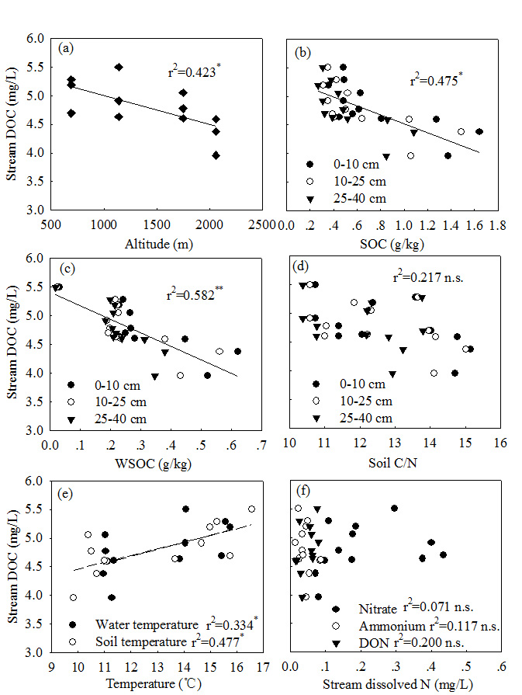

Fig. 4 Seasonal variations of (a) headwater stream DOC, (b) nitrate, (c) ammonium, (d) DON concentrations (mean±SD, n=3) in the evergreen broadleaf forest (EBF), coniferous forest (CF), subalpine dwarf forest (SDM) and the alpine meadow (AM) in the Wuyi Mountains of China

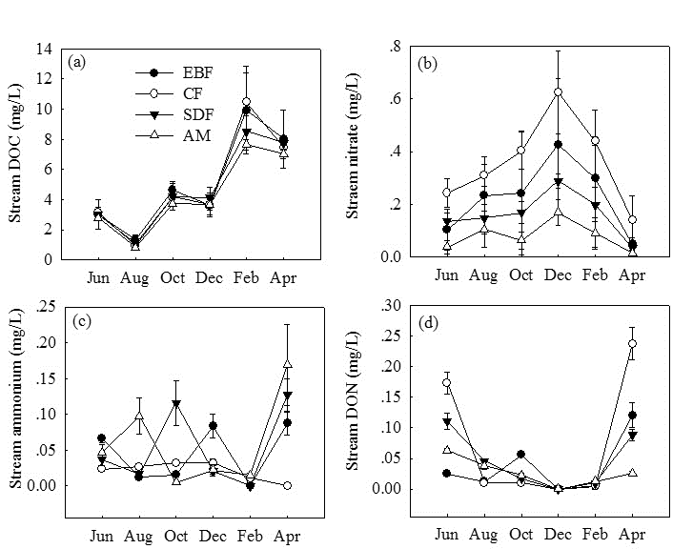
Fig. 5 Correlations between headwater stream DOC concentrations and stream nitrate concentrations of the antecedent two months in the (a) evergreen broadleaf forest (EBF), (b) coniferous forest (CF), (c) subalpine dwarf forest (SDF) and (d) alpine meadow (AM) in the Wuyi Mountains of China. (n=18; * and ** indicated signiﬁcant levels at 0.05 and 0.01 level).



